Embedded Virtual Sensor for Lithium-ion Batteries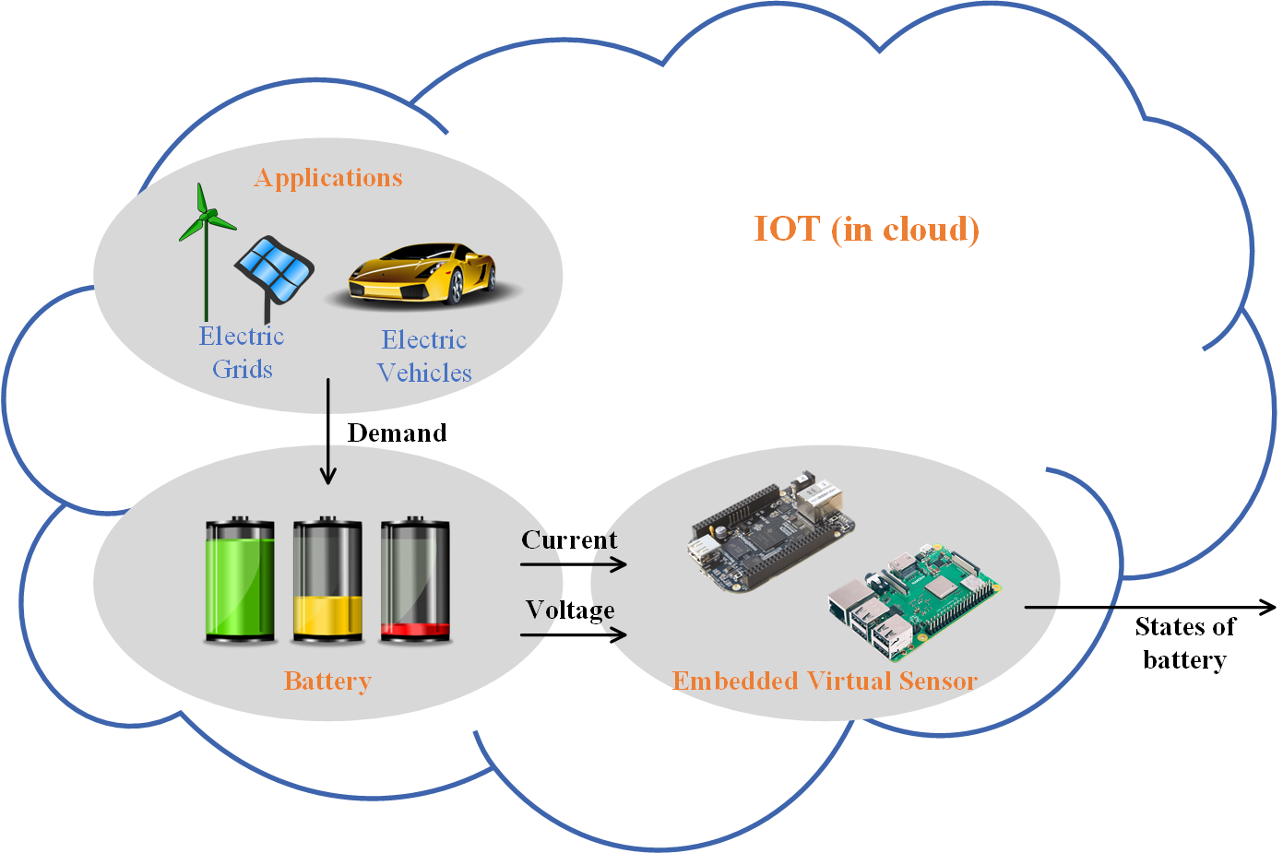

Lithium-ion Battery Monitoring System (BMS)

# Background

The main focus of this project is to improve the computational efficiency of the embedded virtual sensor for lithium-ion batteries. The embedded virtual sensor is designed using a micro-controller, such as Beaglebone Black (BBB) or Raspberry Pi 3. It estimates the states of the battery in real-time and in the cloud. In this project, the students are expected to improve the computational efficiency of the C program embedded in the embedded virtual sensor for improved real-time estimation.

With a growing demand for clean energy, lithium-ion batteries are widely adopted in electric vehicles (EV) and micro grids as energy reservoirs to store energy for future needs. Comparing to conventional batteries, lithium-ion batteries are well-known for their higher energy density, long lifespan, and low self-discharging rate, thereby increasing the number of lithium-ion batteries used in our everyday life. However, without proper usage, the lithium-ion batteries may be permanently damaged or result in catastrophic events, such as explosions or fires.

The catastrophes are mainly the result of inaccurate battery State-of-Charge (SOC) estimation. The SOC indicates the ratio of the Coulombs/charge that remains in the battery to the battery’s total charge capacity. It, however, cannot be directly measured using a sensor; it has to be estimated based on the load current and terminal voltage of the batteries. Even though researchers proposed numerous algorithms in pursuit of accurate SOC estimation, the heavy computational demand prevents the algorithms from being transferred from laboratory to industry.

# Project Description

In this project, the students will learn the concept of batteries and the prevailing SOC estimation algorithms. The project milestones are:

1. Comprehend the working principles of the SOC estimation algorithms.
2. Analyze the performance of an existing SOC estimation algorithm programmed in C.
3. Identify ways to improve the efficiency and performance of the C program.
4. Improve the software performance and benchmark the improvements

Through the project, the students will have a good understanding on the state-of-the-art battery SOC estimation and hands-on experience in C programming optimization skills.